**Experiment 8**

**Aim:**

**To Study Project Scheduling Using Gantt Chart in ClickUp**

**Theory:**

# Introduction to Project Scheduling

Project scheduling is a crucial aspect of project management that involves planning, organizing, and controlling project tasks to ensure timely completion. A well-structured project schedule helps teams coordinate activities, allocate resources efficiently, and track progress against deadlines.

Traditionally, project managers used manual methods like spreadsheets or paper-based scheduling techniques. However, modern project management tools like ClickUp offer advanced digital scheduling solutions that enhance efficiency, accuracy, and collaboration.

# Project Scheduling in ClickUp

ClickUp is a cloud-based project management platform that provides a range of tools for scheduling, tracking, and managing tasks efficiently. One of its most powerful features is the **Gantt Chart**, which enables project managers to visualize the project timeline, track dependencies, and monitor progress.

**Key Features of Project Scheduling in ClickUp:**

1. **Task Creation & Scheduling:**

○ Users can create tasks, set due dates, and define priorities.

○ Tasks can be categorized into different stages such as **To Do**, **In Progress**, and **Completed**.

1. **Gantt Charts for Visual Scheduling:**

○ ClickUp provides an **interactive Gantt Chart** that visually represents the project timeline.

○ Tasks are displayed along a timeline, making it easy to understand project flow.

1. **Task Dependencies:**

○ ClickUp allows project managers to set **task dependencies**, ensuring that tasks are completed in the correct order.

○ Example: A **design phase** must be completed before the **development phase** can begin.

1. **Resource & Workload Management:**

○ ClickUp’s **Workload View** ensures tasks are evenly distributed among team members.

○ Managers can monitor who is overloaded and reassign tasks accordingly.

1. **Time Tracking & Reporting:**

○ Built-in **time tracking** enables team members to log work hours.

○ Reports help managers evaluate efficiency and make data-driven decisions.

1. **Automation for Efficiency:**

○ ClickUp offers **automation features** that trigger actions based on predefined conditions.

○ Example: When a task is marked "Completed," it can automatically notify the next team member in the workflow.

1. **Collaboration & Communication:**

○ Teams can use ClickUp’s **comment section**, **chat**, and **document-sharing** features to communicate effectively.

○ Integrations with tools like **Slack**, **Google Drive**, and **Microsoft Teams** enhance productivity.

**Benefits of Project Scheduling Using ClickUp:**

* + **Better Time Management:** Helps teams stay on track with deadlines.
  + **Improved Productivity:** Reduces confusion and enhances task execution.
  + **Clear Task Prioritization:** Ensures high-priority tasks are completed first.
  + **Enhanced Team Collaboration:** Centralized platform for seamless teamwork.
  + **Real-time Progress Monitoring:** Enables proactive problem-solving.

***Implementation:***

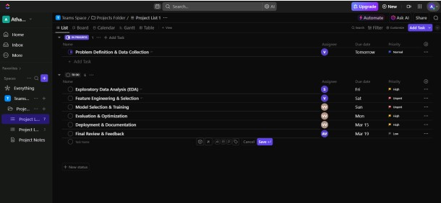

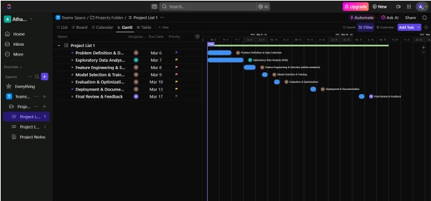

.

# Conclusion

Thus we have successfully implemented Project management using ClickUp.